CalcuCafé Specifications

Introduction

**Summary**

*What are we doing? What’s the intent and outcome?*

We are designing a cost of production calculation tool for smallholder coffee farmers and cooperative technicians in Latin American coffee-exporting countries.

*Why are we doing this?*

Our tool will take in farmer-generated production inputs to generate a breakdown of their cost of production, which will help Fair Trade determine a fair price paid to farmers.

*What problem are we solving?*

We are solving the problem of a lack of transparency in the coffee production industry by providing farmers with a tool to understand their cost of production and make decisions to support the economic viability of their smallholder production practices.

User Flow: Farmers

Farmers can 1) log in [login.html] or 2) sign up [index.html]. Sign up takes you to the 3) inputs page [inputs.html], which takes you to the 4) results page [results.html], while log in takes you directly to the results page. From the results page, you can return to the inputs page, 5) export the result data, or to the 6) simulations page [whatif.html] to run a simulation on the result data. The simulations page allows you to run simulations and return to the results page or inputs page. 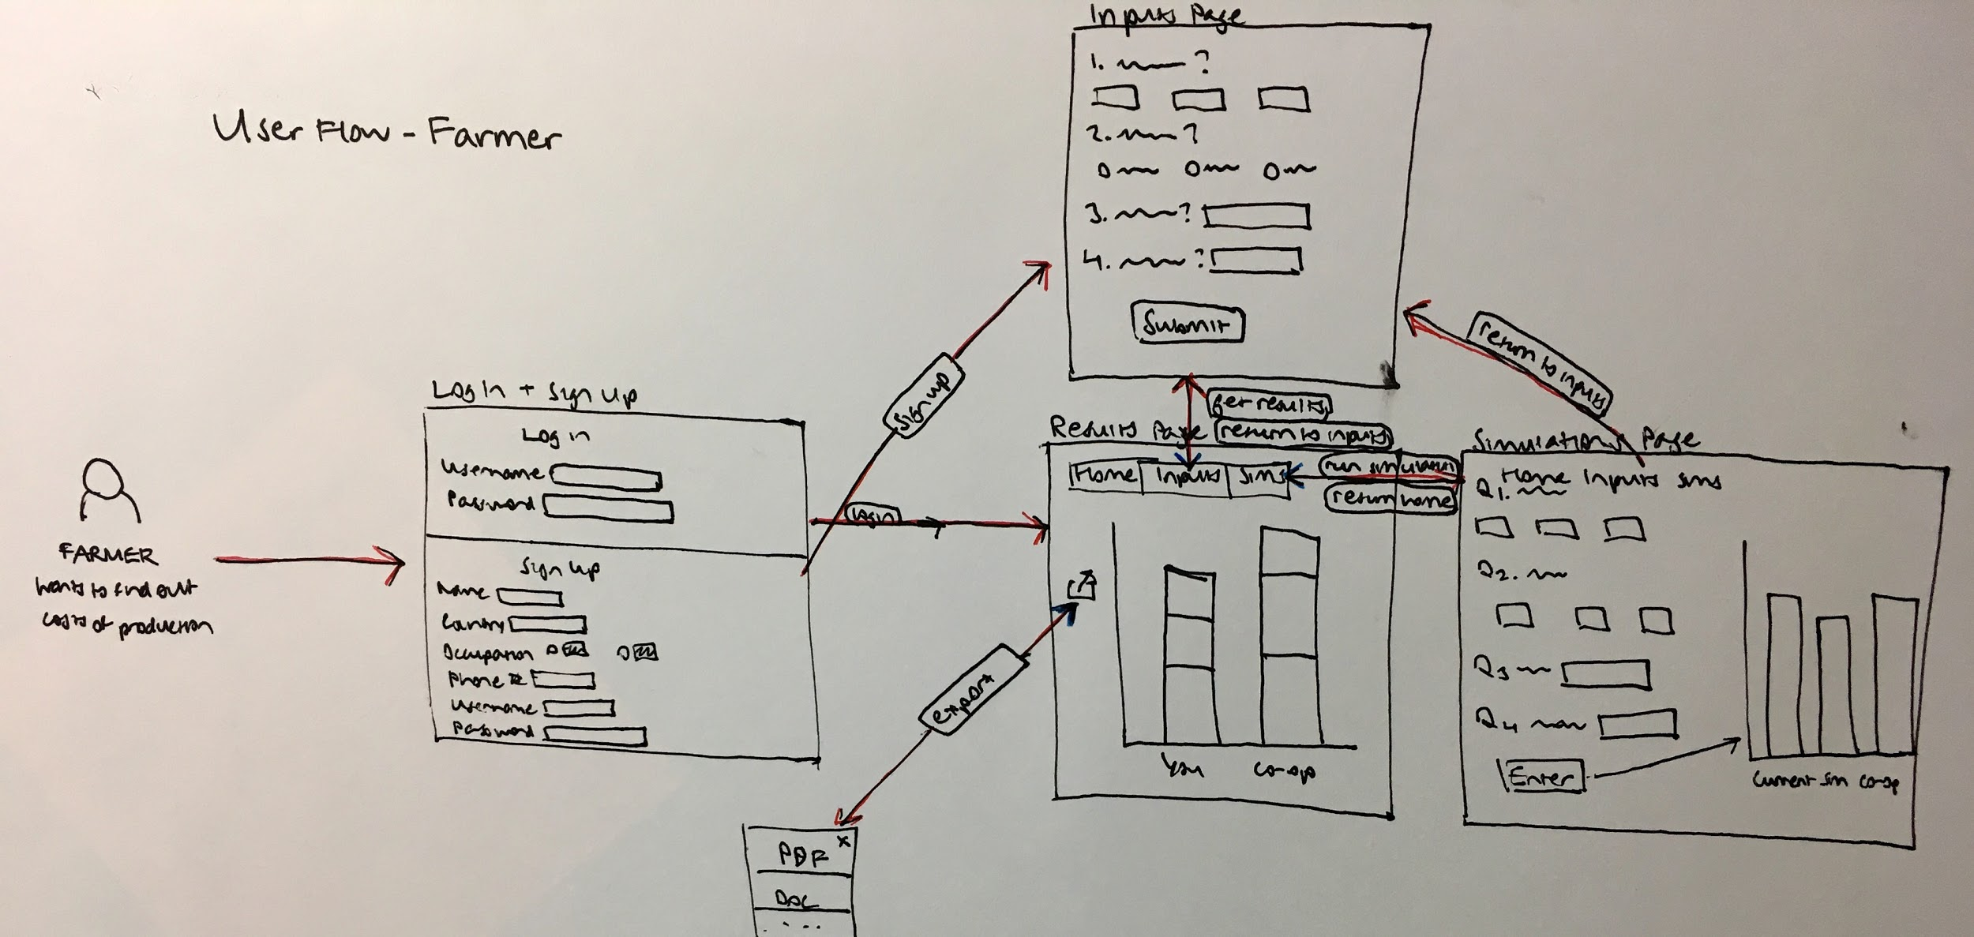

Add error messages in screens

Sign Up/Login (index.html)

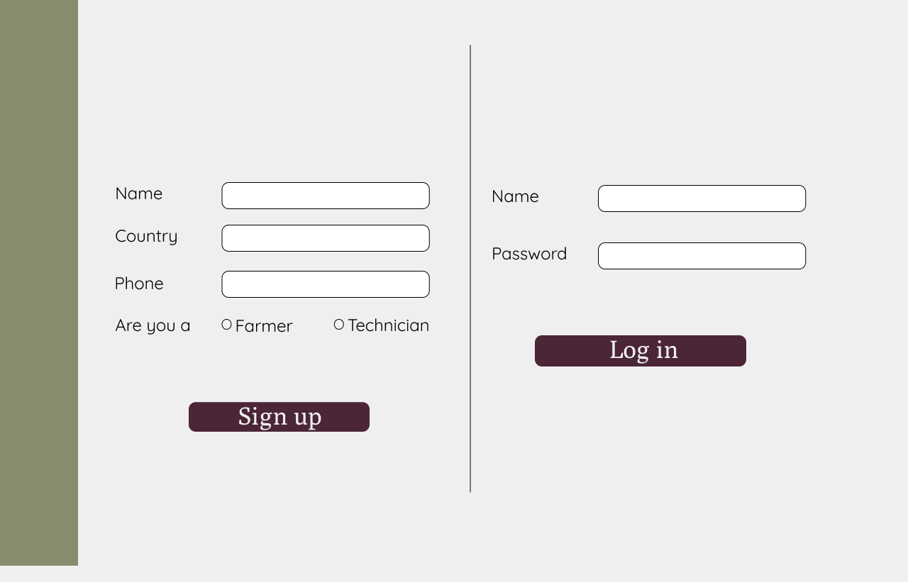

1. This mock screen combines the current login and sign-up screen
2. We will be using their name as the user name
3. They will be assigned a password that will be given to them by the cooperative president.

**Purpose:** The purpose of this screen is to allow users to either log in or sign up for the cost of production tool.

**How to get to this screen:** This will be the first screen they see.

**Description:** There are two sides on this screen; the left side is intended for new users to sign up for an account. The rights side is intended for returning users to log back in. After entering their login information (name and password), users will be directed into the cost of production tool. New users will sign up by entering their name, occupation, country and phone number. After entering this information they will click sign up and will be directed to the next screen of the prototype. In this iteration the signup screen will be on the left and the login up screen will be on the right. If the user clicks sign up or login without entering all of the information they will be unable to continue. The screen will reload with the missing fields highlighted in red. Similarly, if a returning user enters the wrong information for name and password they will receive an error message reading “The username or password is incorrect.”

Inputs Page (inputs.html)



1. Change Names
   * Young -> producción inicial,
   * Mature -> producción máximo (peak)
2. Include 2 additional Questions (see Juan’s Excel file)
   * How much do you pay in soles to transport your coffee from the farm to the collection center in one year? ( icon [link](https://drive.google.com/open?id=0By9jYE2YqtFIMmVhOG9iZThTV28) )
   * What price did you received per quintal of coffee?( icon [link](https://drive.google.com/open?id=0By9jYE2YqtFIMG9XT2lSXzQtQkE))
3. Any fields that are left by blank by the user should receive a value of 0
4. Change icon for Organic ( icon [link](https://drive.google.com/open?id=0By9jYE2YqtFIQTczWlB3djdjMVE) )

5. Change icon for Productivity ( icon [link](https://drive.google.com/open?id=0By9jYE2YqtFILUVOTDNka0RuYnM) )

**Purpose:** The purpose of this screen is to enter information about the farmer’s productivity and farm to accurately show them a comparison of their farm’s and the cooperative’s productivity.

**How to get to this screen:** the farmer gets to this screen from the inputs tab on the top. Also, when a user firsts signs up they go directly to this screen.

**Description:** Each question and icon (6 total) represent an input item and each blank space is a field where users can enter numbers. The first three icons correspond to the first question: three plants with increasing leaves (initial production, peak production, old). The next three icons correspond to the organic, conventional, in transition labels in the second question. The third question only has one icon, an individual with a shovel, to represent average pay of the day laborers. The last question only has one icon as well, (icon) to represent productivity. Question 2 is a radio button where users can only select one choice. User’s will input the number of hectares of each type of tree they have process of production, average daily pay for laborers, and productivity, transport costs, and price received. After entering this data users will click submit and be directed to a graph representation of their productivity on the results page. If the user clicks submit without entering all of the data for the first question, it will be assumed the value for that input is zero. If the user doesn’t submit a response for questions 2-6 they will be unable to proceed and the screen will reload with the missing fields highlighted in red. For the current iteration, the titles and corresponding images on the inputs page will be changed. For “How many hectares of each tree do you have?” the categories will be “initial production,” “peak production,” and “old.” In question 2, we plan to change the bird icon to something more appropriate for “organic.” In question 4, we plan to change the coffee bean icon to complement the term “productivity.” These changed icons are linked above.

Results Page (Results.html)



1. Add the numerical price to Current Price line: i.e. $1.16
2. Make collapsible legend function more clear (make key items look like buttons)

**Purpose**: Display cost breakdowns of farmers’s expenses. This screen also allows the farmer to compare their cost breakdown to the cooperative averages .

**How to get here:** This screen will be accessible in multiple ways. Primarily, it will be the first screen that returning users see when they log-in. For new users, it will be accessible after hitting “submit” on the inputs page. For returning users it is also accessible through the home tab on the nav bar.

**Description:** This screen will be the first screen that users go to when they log-in for the second time or beyond. This page page features a graph that shows that farm’s cost break down compared to the cooperative average. The legend at the bottom is interactive and clicking on the label will hide that part of the page. The export button wil allow the user to export this graph and its underlying table to an excel doc or print this page. We will add the numerical price to the current price line. For example, on this graph the current price of S/1.16 would be shown. Currently a text box appears when you hover over the graph, that will not be implemented going forward and will be replaced with an on-boarding sequence. No user inputs are needed on this page.

Simulations Page (whatif.html)



1. On left side, same changes as noted for inputs page
2. Remove co-op bar from bar charts
3. Add the numerical price to Current Price line: ie. $1.16
4. Remove enter button, graph should adjust automatically when new numbers are inputted

See below for how this screen might work on a vertical mobile screen.

**Purpose:** To demonstrate to users the impact of changing variables on their productivity.

**How to get here:** This screen is accessible through the Simulations tab.

**Description:** The purpose of this screen is to demonstrate to users how changing variables affects their price and productivity in comparison to their current farm, as well as the cooperative. The left side of the screen will be auto-populated with the information they inputted on the inputs screen to being , but users will be able to adjust the numbers. The right side is a graph displaying the current and simulated breakdowns. When an input is changed on the left, the simulated bar on the right should change to reflect that changed input. The enter button will be removed, as the simulation graph should change automatically. Also the cooperative bar will be removed to simplify the graph.

Mobile Mock-up for Simulation Screen

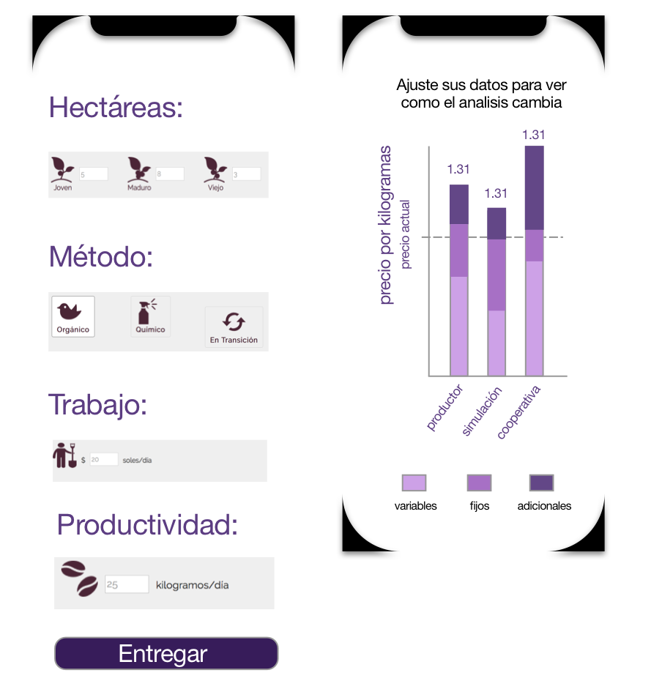

**Mobile description:** For the next iteration, we will make the prototype responsive to address the users’ preference for mobile interfaces. These screens represent the mobile version of the input and simulation screen. To make these feature usable we are dividing the single screen shown above (of the web simulations page) into separate screens for mobile. The left screen shows what the input mobile page will look like. It will have all the same functionality as the web screen and will scroll vertically to access all inputs. Once the user presses “Entregar” they will be taken to the screen on the right, showing the simulation productivity in comparison with the user’s farm and the cooperative.

In the next version, we will be using When The new labels: “initial production,” “peak production,” and “old.” The new icons will also be used in place of the bird icon (organic) and and coffee bean icon (productivity).

Onboarding Series

Purpose: Providing a preview of the application while explaining some of the economic concepts we use.

How to get there: The first time a user uses this tool, this onboarding should appear. It should not appear for those who have used the tool before.

Description: This is a series of screen, that the user can move through by clicking next. All of the screens are static except for the next button. After the last screen it should go to the account sign-up/login.